Fatih University

Department of Computer Engineering



CENG 217 Object Oriented Programming

Term Project Report Template v0.1

Project Name

First and Last Name 1, Student Number 1
First and Last Name 2, Student Number 2
First and Last Name 3, Student Number 3

Version 1.0

Start Date: 15 December 2002

16 January 2003

Confirmation

First and Last Name  Title  Department |  | First and Last Name  Title  Department
First and Last Name
Title
Department
Halûk Gümüşkaya  Associate Professor  Computer Engineering |  | Engine Tozal  Master Student, Assistant  Computer Engineering

Chapters and Authors Table
The chapter authors and inspectors are given in the following table:

Chapters | Authors | Inspectors | Comments

Preface
An introductory paragraph explaining the project and this document is given in this section. This is the controlling and presenting document for managing a software project, and it defines the technical and managerial processes necessary to deliver the project requirements.

A course project is a vehicle for you to take an active part in exploring the subject area, as appropriate for an advanced study. The project is also intended as a useful prototype experience for those going on to advanced design work or research. Thus, a project must be chosen that will clearly extend your knowledge and understanding of some area of Object Oriented Programming (software development) using Java. Moreover, the primary criterion for evaluating your project will be what you have learned and discovered from the project, not the amount of work involved or the amount of code written or the number of pages of written report. Thus, you should define your project with this strongly in mind and prepare submissions that communicate what you have learned to the instructor and the assistant.
When designing a project to do “Object Oriented X”, getting the “Object Oriented” part right is more important than getting the “X” part right. For example, if you want to build an object oriented game, the majority of your time should be spent on the object oriented aspects of the game, not on the graphics.
There are minimum five aspects of a software project:

1. Project Definition and Organization
2. Technical and Literature Background
3. Software Requirements and Specifications
4. System Architecture Design
5. Implementation

The Project Definition and Organization should explore project overview and objectives, project work products and their delivery dates. In this section, you will also describe the critical success factors, the vision statement, risk management plans, and roles of individuals on the project.
The Technical and Literature Background should summarize technical documents and the research literature (for senior and graduate students and for some advanced studies) which are the background of your project. For technical or junior projects this section might be quite short.
The Software Requirements and Specifications should give all high level, generally non-technical, user requirements. You should develop a Requirements and Specifications document by interviewing the end users and other related people before starting the detailed architecture design and implementation. If UML is used, use case diagrams are produced at this phase. The user interface drawings and interactive user interface prototypes are also developed at this stage.
The System Architecture Design should try to map out a software solution that is implementable with the available time, people, knowledge, and computer resources. With the intended “prototyping” nature of the projects, design, implementation and evaluation may be performed iteratively. However, there is merit in trying to think things through before doing at each iteration.
In the Implementation phase, you will give your project implementation platform, software tools, development and testing processes if used in the project. Finally, you will include the source code with its documentation.

Figures and Tables
The figures and tables of the document are given with their titles, numbers and page numbers in this section. The figures, tables and their page numbers should be updated before you take a print out. To update the figures and tables section, do a right-click on one section, and choose Update Field/Update Entire Table. When necessary you should also update the Contents table which is given in the following this page.

Figures

Figure 4.1. The UML class diagrams of a sample project. 6
Figure 6.1. A sample project web page (1). 11
Figure 6.2. A sample project web page (2). 11

Tables

Table 1.1. Project members and their roles. 2
Table 5.1. Project computers. 7

Contents
Confirmation ii
Chapters and Authors Table iii
Preface iv
Figures and Tables v
Figures v
Tables v
Contents vi
1. Project Definition and Organization 1
1.1. Project Overview and Objectives 1
1.2. Critical Success Factors 1
1.3. Vision Statement 1
1.4. Risk Management 1
1.5. Project Members and Their Roles 1
2. Technical and Literature Background 3
3. Software Requirements and Specifications 4
3.1. A Simple Requirements Development Process 4
3.2. User Interface Design 4
4. System Architecture Design 5
4.1. Technical Description 5
4.2. System Architecture 5
4.2.1. Hardware Architecture 5
4.2.2. Software Architecture Block Diagrams 5
4.2. Reusability 5
5. Implementation 7
5.1. Development Platform and Software Tools 7
5.1.1. Hardware Platform 7
5.1.2. Software Platforms, Development Environments and Tools 7
5.2. Development and Testing Processes 7
5.2.1. Development Proces 7
5.2.2. Testing Process 7
5.3. Source Code and Its Documentation 7
5.3.1. Coding Standard and Minimum Documentation Requirements 8
5.3.2. Source Code 8
6. Appendix 10
6.1. References 10
6.2. Project Web Site 11

1. Project Definition and Organization

1.1. Project Overview and Objectives
Give a short summary of the project objectives, project business case, the software to be delivered, major work products and delivery dates, delivery method (email, FTP, CD, etc.), delivery locations, major milestones, major activities, required resources, and top-level schedule and budget. Describe the relationship of this project to other projects, if appropriate.

1.2. Critical Success Factors
Give the key factors that will make the project a success. (e.g. delivery of software work products on time, writing 5,000 lines of code a month in a professional manner with documentation, learning targeted new topics and developing a working software, …)

1.3. Vision Statement
Before the project gets started, a team needs a common shared vision. The vision statement must be compelling and achievable. The vision statement should make it easy to determine what should go into the software and what should not. A vision statement such as “Create the world’s best word processor” might be motivating, but it will not provide much guidance to the development team other than telling them to throw every conceivable feature into the software. Alternatively, a vision statement such as “Create the world’s easiest-to-use word processor” provides just as elevating a mission for the team to form around but provides much better guidance about what features to exclude.

1.4. Risk Management
Practices recommended specifically for risk management include the following:
- Planning for risk management in the Software Development Plan (this document).
- Identification of a risk officer
- Use of a top 10 risks list.
- Creation of a risk-management plan for each risk
- Creation of an anonymous risk-reporting channel
The project should identify a risk officer, who is a member of the project (preferably someone other than the project manager) responsible for spotting emerging risks. Continually looking for potential problems, the risk officer tries to pick apart the risk-management plans for each risk. He or she should have management’s respect; otherwise, the risk officer simply becomes the project’s “designated pessimist”. Often a senior developer or tester makes a good risk officer.
A Top 10 Risks List, which is a list of the top risks the project faces at any given time, can be used as the key risk-management tool. The simple act of maintaining a list of current risks helps to keep risk management at the forefront of the project team’s mind. The project team should create a preliminary risks list before beginning requirements work and then keep the list current through the end of the project. It isn’t important that the list contain exactly 10 risks. It can contain 5 risks or 15. What is important is that it is maintained regularly.

1.5. Project Members and Their Roles
List the roles of individuals on the project. A project team, no matter what size, needs to differentiate among the various roles played by team members. On small projects, several roles may be performed by one person.
The mostly used project roles in a software project: Project manager, product manager, architect, user-interface designer, developer, quality assurance/tester, risk officer, end user documentation specialist.
Table 1.1. Project members and their roles.
Project Member | Roles

2. Technical and Literature Background
You should summarize technical documents and the research literature (for senior and graduate students and for some advanced studies) which are the background of your project. For technical or junior projects this section might be quite short. For senior projects you should examine and summarize the selected area, according to what are the important problems, to what degree are these problems understood and solved, how do different solutions interrelate, and what are the important issues for the future.
Original thoughts, solutions, insights are strongly encouraged and will be rewarded. Because of the time limits of the semester and our emphasis on software implementation, this stage is generally expected to be very limited, e.g. read a couple of papers and technical documents, think hard for awhile and write your project proposal.

3. Software Requirements and Specifications
This chapter must give all high level, generally non-technical, user requirements.

3.1. A Simple Requirements Development Process
- First identify a set of key end users and other people who collectively have the credibility to define the software that the team is building.
- Interview the end users and other related people to create a set of preliminary requirements.
- List the most important requirements; produce a requirements and specifications document and show this document to the users and other related people.
- If UML is used, draw Use Case diagrams and show these diagrams to the users and other related people and get their feedback and improve the requirements and specifications document and Use Case diagrams.
- Draw user interface drawings and show them to the users and other related people.
- Build simple, interactive user interface prototypes and show them to the users and other related people.

3.2. User Interface Design
The first prototypes of the program’s important graphical user interface should be developed at the beginning of the project. The GUI components can be designed using a drawing tool, like MS Visio.

4. System Architecture Design
The architecture chapter presents the diagram-intensive detailed system design. The complete static and dynamic view of the system is designed and given in this section.

4.1. Technical Description
A short technical description of the project is given here.

4.2. System Architecture

4.2.1. Hardware Architecture
If the developed project needs some special devices, hardware configurations or it is a network project, you should give the hardware architecture and special hardware configurations.

4.2.2. Software Architecture Block Diagrams
You should give the software architecture in this section. The architecture should describe what communications are allowed among the different subsystems. A good architecture holds communications among subsystems to a minimum.
Some architectural features of a software project are listed below:
- Client/server, peer-to-peer communication models
- Two-tier, tree-tier or n-tier architectures
- Database design
- Concurrency
- Message passing
- Special communication protocols
If UML is used in the software design process, more detailed use cases, package diagrams, class diagrams and sequence diagrams of some important interactions are produced and given in this section. A figure showing UML class diagrams of a sample project is given in Figure 4.1. If your figures are big, put them in landscape form as shown in the figure.

4.2. Reusability
From the beginning to the end of the life cycle, the approach to software development recommended by the NASA SEL (Software Engineering Laboratory) stresses the principle of reuse. The reuse of existing experience is a key ingredient to progress in any area. Without reuse, everything must be relearned and re-created.
In software development, reuse eliminates having to “reinvent the wheel” in each phase of the life cycle, reducing costs and improving both reliability and productivity. Planned reuse is a primary force behind such recent technologies as object-oriented design, Java, and C++/C#.
Analyze these key elements of a project for possible reuse:
- Software development process
- Requirements characteristics
- Software architecture and design concepts
- Test plans and procedures
- Code
- User documentation
- Staff

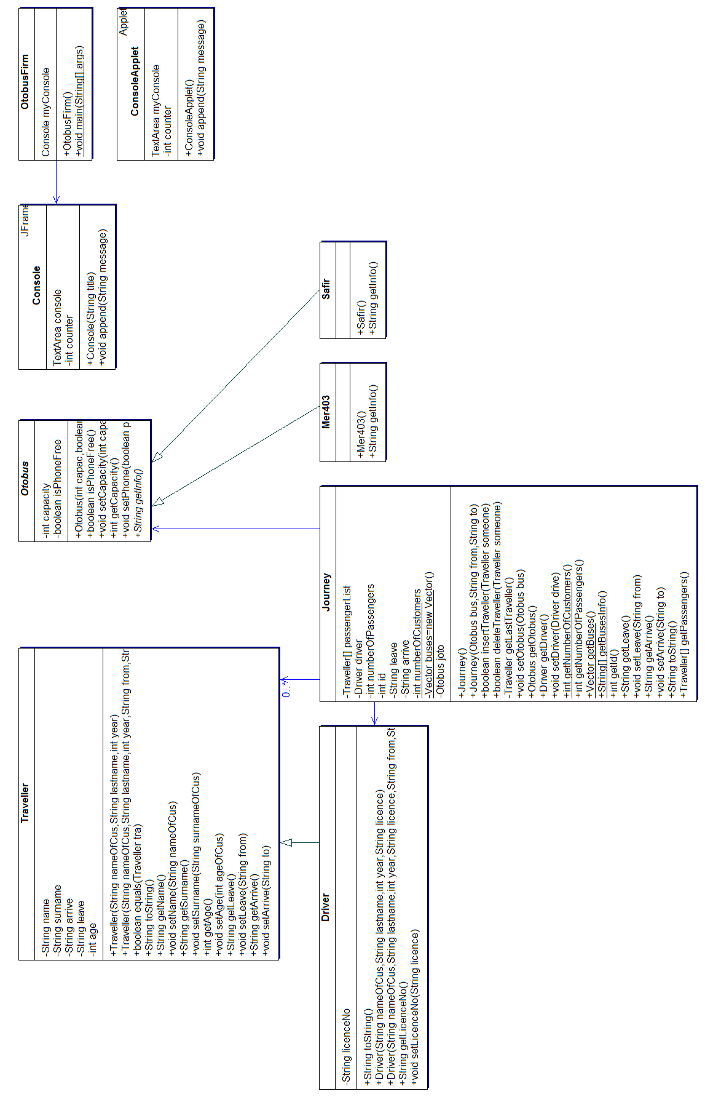 | Figure 4.1. The UML class diagrams of a sample project.

5. Implementation
In this section you will summarize your project implementation platform, software tools, development and testing processes if used in the project. Finally, you will include the source code with its documentation.
Include your final screen captures of your working program. It helps me to remember your demo, and shows that your program is working, at least partially! You can use a drawing program (like VISIO) to draw your program logic and program flow. Don’t forget “A picture worths a thousand words”. Use similar ways (screen captures, drawings, pseudo code, comments) to explain what you have done with your code if needed.

5.1. Development Platform and Software Tools
Some architectural features of a software project are listed below:

5.1.1. Hardware Platform
Write the project computers and other hardware used in the project development in this section. You can use a similar table given in Table 5.1.
Table 5.1. Project computers.
Project Member | CPU | RAM | Hard Disk | Monitor

5.1.2. Software Platforms, Development Environments and Tools
Write the operating systems, software development environments and other tools used during the project development.

5.2. Development and Testing Processes

5.2.1. Development Proces
If some professional development processes are followed during the development of the project give brief information about the project processes. Some examples are given below:
- The project’s lifecycle model (e.g., waterfall model, spiral model, evolutionary prototyping model, etc.)
- Some processes from heavy processes like CMM or SPICE
- Some processes from agile processes like Extreme Programming
- Some other best practices

5.2.2. Testing Process
Explain your testing process in this section.

5.3. Source Code and Its Documentation
“Write your program for people first, computers second”. (A rule from Code Complete, Steve McConnell, Microsoft Press, 1993.) This is especially true and very important when you are writing for your course, and for a big project. If your project report and program print-out is not good, (program function and variable names and code descriptions are not clear, and code indentation is bad), your instructor will not try to understand what you have done. And also, your product will not be able to be used by other people (maybe, by your project team members). Even sometimes you can not remember what you have done with your own code when you look at it later!

5.3.1. Coding Standard and Minimum Documentation Requirements
You should follow the Java style coding standard. Give your coding standard reference you applied in you project.
Look at some long more technical documents like Doug Lea’s Java Coding Standard page or Sun’s Java Code Conventions. There are many good common best practices and advices to prepare good software and documentation on similar documents.
Your software documentation should satisfy the following minimum requirements:
- First list the names of the files you have written explaining the tasks of each file with one sentence.
- Each file should have a comment header at the top with your name, a brief description of what the program is, and any special compiling instructions.
- Most classes (functions) should be short, and each should do only one thing. No class (function) should ever be more than 50 lines (or one computer secreen page) in general.
- Each class (function) should have a brief comment describing what it does. It is not necessary to comment every line, and if your code is well written, it should not require a lot of in-line commenting. However, you should use comments to describe any unusual code or hard to follow code or complicated code, and describe any non-obvious variables.
- Classes, objects, methods (functions) and variables should have meaningful names, but you can use single letters like i for loop counters and such.
- Minimize the number of global variables and objects.
- All code must be written by you (or your project team in team works) and you alone, except that you can use and modify any sample code from other sources or from class as long as you provide credit to the source.

5.3.2. Source Code
The program source code should be in 8-point Courier New characters. Please pay attention to the code indentation. If you use TAB characters for white spaces (code indentation) when writing your program in any editor, you can copy and then paste that program into your Microsoft Word document without any problem in general. After you have copied your programs into the project document, if there are some lines which are not aligned, correct them manually.
If your program is not large (more than 3,000 lines of code), include all program in this section. A very simple example source code is given below:

// Banking Project Files:

// Interface: Set of remote methods for a banking service.
BankingInterface.java

// Implements a remote banking object.
BankingImpl.java

// Defines the Account object.
Account.java

// Defines a generic banking exception for banking interface.
BankingException.java

// Defines a simple Insufficent Funds exception for banking interface.
InsufficientFundsException.java;

// Defines an exception for an invalid account and indicates
// which account was invalid. Also allows an error string.
InvalidAccountException.java;

//==================================================================================
package chat;

/**
* Title: ChatServer.java
* Description: This is the server file. (Since this code example is short, it does not
* need a long description.)
* Copyright: Copyright (c) 2003
* Company: Fatih University-Computer Engineering Dept
* @author Haluk Gümüşkaya
* @version 1.0
*/

import java.rmi.*;
import java.rmi.server.UnicastRemoteObject;

// Run the server application by creating ChatServerImpl object
public class ChatServer {
public static void main(String[] argv) {
System.setSecurityManager(new RMISecurityManager());

try {
ChatServerImpl implementation = new ChatServerImpl("ChatServices");
System.out.println("Chat Server is ready");
}
catch (Exception e) {
System.out.println("Exception occurred: " + e);
}
}
}

6. Appendix

6.1. References
List all the documents, books, Internet resources and other materials used and referenced in the project. This section is like the bibliography in a published book.

- L. Raman, “OSI Systems Network Management”, IEEE Communications Magazine, March 1998, pp. 46-53.
- A. Pras, Network Management Architectures, Ph. D. Thesis, CTIT (Centre for Telematics and Information Technology) Ph. D-thesis series No. 95-02, Netherlands, 1995.
- Summit Online for Enterprise Management: http://www.summitonline.com.
- Lantimes Network Management Articles: http://www.lantimes.com/subject/netmgt.html.
- International Telecommunication Union, “TMN Management Functions”, Rec. M. 3400, 1993, http://www.itu.int/itudoc/itu-t/rec/m/index.html.
- ISO 9596, Information Technology⎯Open Systems Interconnection⎯Common Management Information Protocol, Int’l Organization for Standardization, Geneva, 1991.

6.2. Project Web Site
If you have a project web site, put the home page and some other important pages in this section, and briefly explain what you have posted in your web site. Some typical home pages of sample project web sites are given below.
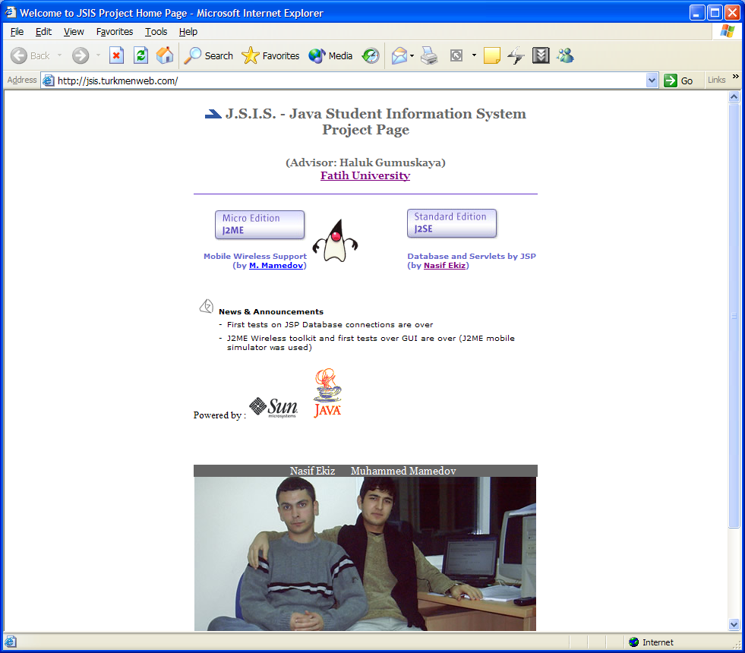
Figure 6.1. A sample project web page (1).
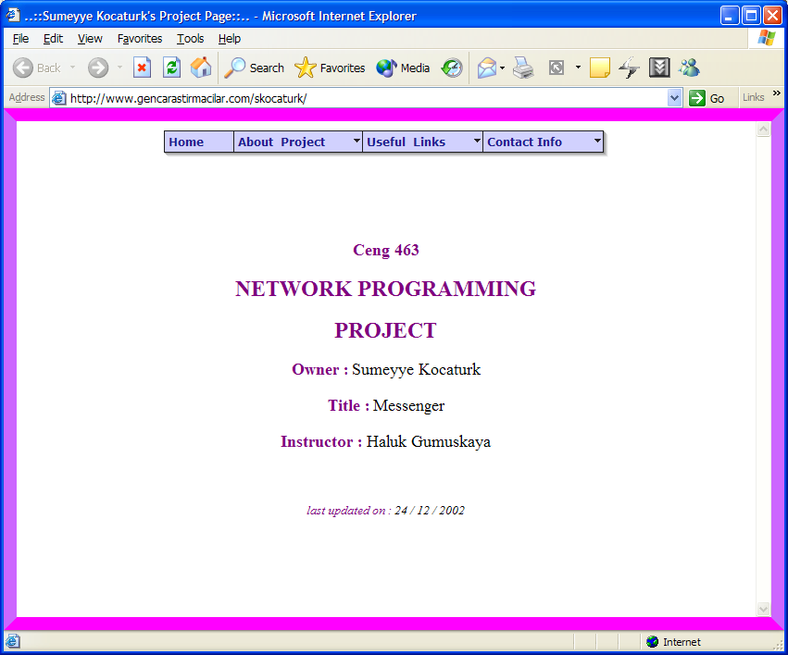
Figure 6.2. A sample project web page (2).

